Unit of a long term plan: Unit 9 Reading for pleasure. |  | School: №28 Akbay
Grade: 5-G |  | Number present: | absent:
Lesson title | Language Focus: Past Simple
Learning objectives | 5.6.1.1 use Past Simple (negative and questions) to speak about past events tell;  5.3.3.1 Give an opinion at sentence level on a limited range of general and curricular topics;
Lesson objectives | Learners will be able to:  • Learn and practise past simple regular and irregular forms.  • Use the past simple to talk about events in the past.
Value links | Gratitude – You value gratitude if you find yourself respecting people who say please and thank you. If you’re a religious person who values gratitude, you may always insist on praying before eating your dinner.
Plan

Stages / Time | Teachers’ actions | Students’ actions | Assessment criteria | Resources
Beginning of the lesson  5 min | Organization moment  1.Greeting.  Ask about the weather.  Warm-up Good wishes  Magic books. Choose one book and read and translate hidden word above the book.  Say when use this words.    Lead – In  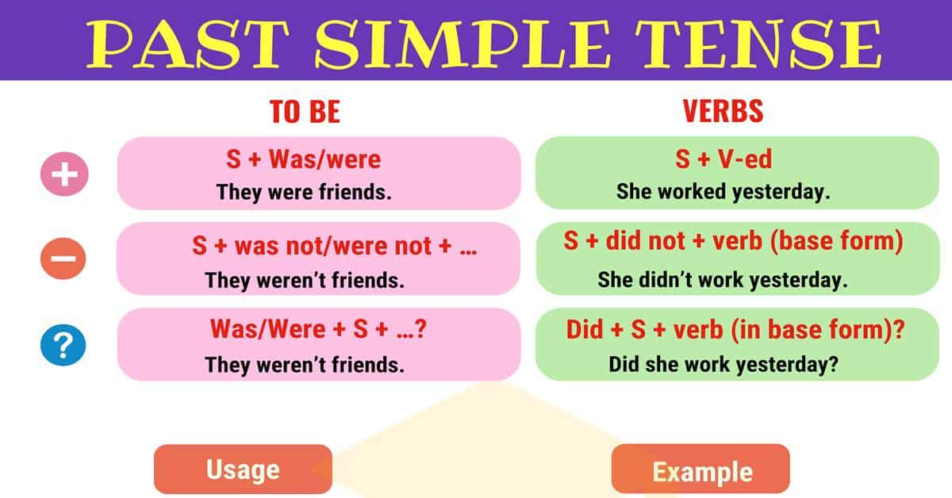  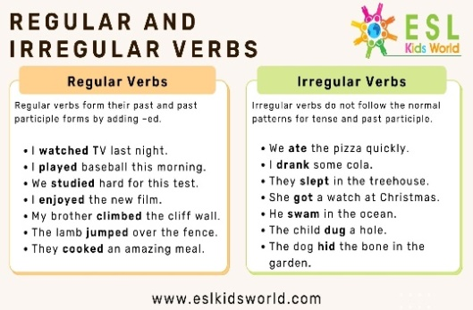  Past Simple Tense! When talking about an action which has happened in the past, you will need to use the past simple tense. However, before you can begin confidently using this tense, it is important to learn the rules which surround it. As with any part of English grammar, the rules of the past simple tense should be applied each time it is used in order to ensure that you are forming grammatically correct sentences. | The aim: To develop Ss speaking skills and create friendly atmosphere  Efficiency: By telling the wishes they show their appreciations .  Choose one book and read than translate | At the organization moment T tries to award active Ss. «The praise» method is used to evaluate Ss with phrases like:  “Good job!  Well done!”  Formative Assessment    Good job!  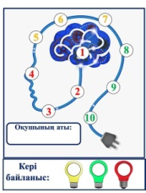  Students mark their scores using this sticker | Pictures  PPT  PPT
Middle of the lesson  Presentation part.  35 min | Task1 Find the irregular and regular verbs from the given words. Make sentences  • do, helped, did, go, pen, family, friend, played, listened, went, football, photo, flower, cat, apple  Differentiation:  «Verbal support» method is used to help Students use verbs in correct form in the past  Task2 Bamboozle game. Group work  • Students choose one number in the bamboozle platform and complete the hidden sentences above the number and check their answers.  • Check answers as a class. | Students find the past simple words and translate and make sentences  Choose one number and complete the sentences. | Assessment criteria  - Learn and practise past simple regular and irregular forms and talk about events in the past.  Descriptor:  - find the past simple words from given words.  Assessment criteria  - Learn and practise past simple  Descriptor:  - complete the sentences with the past simple forms of the verbs in brackets. | Sweets  Worksheets  Sweets
End of the lesson  5 min | Home task:  Ex: 1 P: 61 WB | 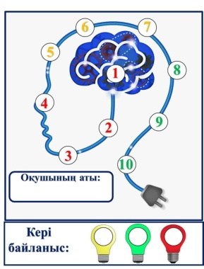 | Students use their stickers to show their knowledge according to the lesson. | Poster  KWL chart  

